***Mohammed Takefi Middle School School year: 2023/2024***

**English Catching Up Exam**

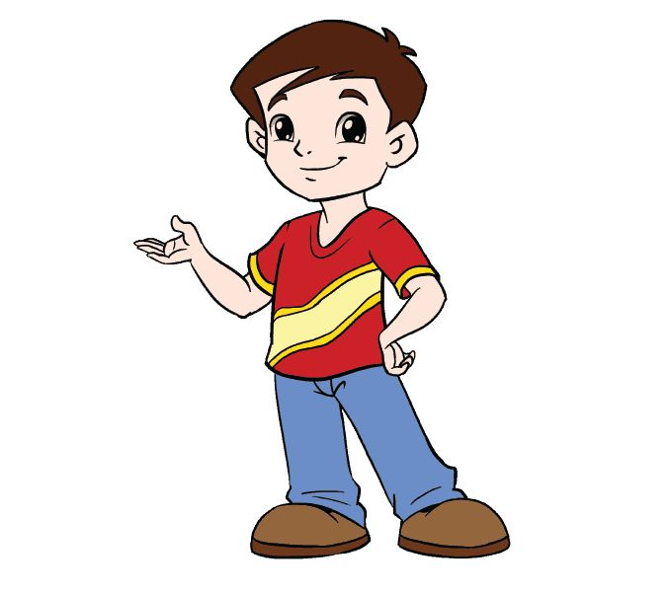**Text**

Hello , my name is Peter . I am 11 years old . I am from Australia and I live in Sydney . I am a pupil at Junior Middle School, it is very beautiful . My friend Jhon is 12 years old . He is from Great Britain .

How about you ?

**Part one:**

**Reading Comprehension: (7pts)**

**Activity 01:** Readthe text and fill in Peter’s profile: (3pts)

Name : ........................ .......

Age : ...................................

Country : ...................... .....

City : ...................................

School : ..............................

Occupation: ……………………………………...

**Activity 02** : Answer by ‘**true**’ or ‘**false**’ : (3pts)

1- Peter is a teacher. (………...............)

2- John is 11 years old. (.......................)

3- Peter is from Great Britain. (.......................)

**Activity 03 :** Find in the text the synonyms of the following words (2pts)

1) Hi = ....................... 2) Nice = ……....................

**Mastery of Language: (7pts)**

**Activity 01** : Replace the underlined words with the appropriate personal pronoun ( she- he- they) (3pts)

1) **Jhon** is from Great Britain . => ...........................is from Great Britain.

2) **John and Peter** are friends . =>...........................are friends .

3) **Chaima** is Algerian . =>...........................is Algerian .

**Activity 02** : Circle the right auxiliary (2pts)

1. Sami ( am – is ) a pupil at Ben Boulaid middle school . He ( is – are ) from Morocco .

2. Sonia and I ( is - are) sisters .

3. You and Mary ( is - are ) 13 years old .

**Activity 03** : Classify the following words in the table (3pts)

Five - play - Nice - Game

|  |  |
| --- | --- |
| / ei / | / ai / |
| -………………………………  -……………………………… | -…………………………….  -……………………………. |

**Situation of integration:**  (6pts)

You have a new friend who wants to know more about you. Complete the following passage to finish writing a short paragraph introducing yourself to your friend.

Dear new friend,

I am very happy to be your new friend. My name is……………………………………… I am…………………………………………..I am a …………………………….at Mouhamed Tekfi Middle School. I am from ………………………………………and I ………………………….in ……………………………………….

My father is an ……………………………….and my mother is……………………………………..

Yours

………………………………..



***Good luck.***